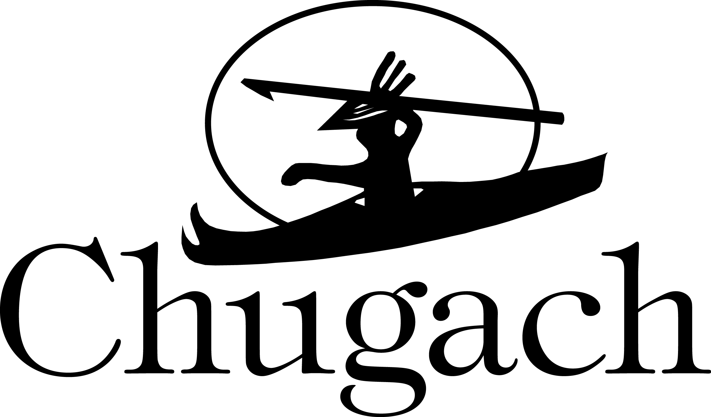 | Disclosure of Debarment or Suspension Status  Certification Regarding Responsibility Matters  (FAR Provision 52.209-5, August 2020)

(a)(1) The Offeror certifies, to the best of its knowledge and belief, that—
(i) The Offeror and/or any of its Principals—
(A) Are not presently debarred, suspended, proposed for debarment, or declared ineligible for the award of contracts by any Federal agency;
(B) Have not within a three-year period preceding this offer, been convicted of or had a civil judgment rendered against them for: commission of fraud or a criminal offense in connection with obtaining, attempting to obtain, or performing a public (Federal, State, or local) contract or subcontract; violation of Federal or State antitrust statutes relating to the submission of offers; or commission of embezzlement, theft, forgery, bribery, falsification or destruction of records, making false statements, tax evasion, violating Federal criminal tax laws, or receiving stolen property
(C) Are not presently indicted for, or otherwise criminally or civilly charged by a governmental entity with, commission of any of the offenses enumerated in paragraph (a)(1)(i)(B) of this provision;
(D) Have not within a three-year period preceding this offer, been notified of any delinquent Federal taxes in an amount that exceeds the threshold at 9.104-5(a)(2) for which the liability remains unsatisfied.
(ii) The Offeror Has not, within a three-year period preceding this offer, had one or more contracts terminated for default by any Federal agency.
(2) "Principal," for the purposes of this certification, means an officer, director, owner, partner, or a person having primary management or supervisory responsibilities within a business entity (e.g., general manager; plant manager; head of a division or business segment; and similar positions).
(3) ”Contractor,” for the purpose of this certification, means Chugach Alaska Corporation or any of its subsidiaries.
This Certification Concerns a Matter Within the Jurisdiction of an Agency of the United States and the Making of a False, Fictitious, or Fraudulent Certification May Render the Maker Subject to Prosecution Under Section 1001, Title 18, United States Code.
(b) The Offeror shall provide immediate written notice to the Buyer if, at any time prior to contract award, the Offeror learns that its certification was erroneous when submitted or has become erroneous by reason of changed circumstances.
(c) A certification that any of the items in paragraph (a) of this provision exists will not necessarily result in withholding of an award under this solicitation. However, the certification will be considered in connection with a determination of the Offeror’s responsibility. Failure of the Offeror to furnish a certification or provide such additional information as requested by the Buyer may render the Offeror nonresponsible.
(d) Nothing contained in the foregoing shall be construed to require establishment of a system of records in order to render, in good faith, the certification required by paragraph (a). The knowledge and information of an Offeror is not required to exceed that which is normally possessed by a prudent person in the ordinary course of business dealings.
(e) The certification in paragraph (a) of this provision is a material representation of fact upon which reliance was placed when making award. If it is later determined that the Offeror knowingly rendered an erroneous certification, in addition to other remedies available to the Contractor, the Buyer may terminate the contract resulting from this solicitation for default.

PLEASE SIGN AND RETURN THIS FORM TO THE BUYER

Company Name:
Signature:
Printed Name:
Title:
Date:

